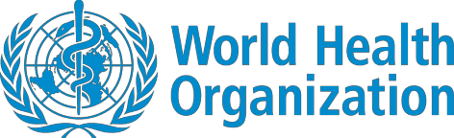

Coronavirus disease (COVID-19)
Situation Report – 107
Data as received by WHO from national authorities by 10:00 CEST, 6 May 2020
This report has been reformatted to improve accessibility for persons with visual impairment.

Highlights

It has been 20 years since the inception of the Global Outbreak Alert and Response Network (GOARN), a close WHO partner which has responded to emergencies in 85 different countries, including the COVID-19 pandemic.

The WHO Regional Director for the Americas, Dr. Carissa F. Etienne, warned that reducing social distancing measures “too soon could accelerate the spread of the virus and open the door for a dramatic upsurge or for spread to adjacent areas”.

In the ‘Subject in Focus’, we provide details on a webinar that WHO hosted yesterday to find out more about how young people are contributing to the COVID-19 response and how they see their future in a post-pandemic world.

Situation in numbers (by WHO Region)
Total (new cases in last 24 hours)

Globally | 3 588 773 cases (71 463) | 247 503 deaths (4102)
Africa | 33 973 cases (1403) | 1202 deaths (90)
Americas | 1 507 148 cases (29 701) | 81 070 deaths (1480)
Eastern Mediterranean | 221 230 cases (7854) | 8290 deaths (175)
Europe | 1 593 828 cases (27 179) | 147 780 deaths (2178)
South-East Asia | 76 998 cases (4310) | 2821 deaths (139)
Western Pacific | 154 884 cases (1016) | 6327 deaths (40)

Subject in Focus: COVID-19 – Learning from the youth of today
As the COVID-19 pandemic has left communities around the world reeling, young people have mobilized their networks and placed themselves firmly in the forefront of the COVID-19 response. WHO hosted a webinar on 5 May, with 808 participants from around the world, to find out more about how young people are contributing to the COVID-19 response and how they see their future in a post-pandemic world.
The panellists included representatives from the Global Health Workforce Network Youth Hub (GHWF Youth Hub), the International Federation of Medical Students’ Association (IFMSA) representing 1.3 million students; the Global Shapers representing over 9000 youths; and the
#MOREVIRALTHANTHEVIRUS global movement with hubs in over 100 countries.
The representative from GHWF Youth Hub highlighted the fact that all over the world young people have stepped up to respond to COVID-19. She spoke about the many healthcare students who have been drawn into delivering care, assisting in contact tracing and working for COVID-19 hotlines and call centres. The representative from IFMSA shared inspiring stories of how young people have helped their own communities by developing technology-driven solutions such as apps to support the delivery of supplies to vulnerable, isolated people; and the creation of an online dashboard to monitor university and school closures around the world while linking online training and alternative learning resources to areas of need. The representative from the #MOREVIRALTHANTHEVIRUS movement described how they started as a group of medical students but soon realized that all students everywhere were affected, and all had something to share and give.
Young people have an unparalleled potential as networkers and amplifiers of information. At the beginning of the pandemic there was a lack of youth-focused communication; this prompted young people around the world to share information. With extensive global networks, digital know-how and creativity, youth organizations and movements can rapidly detect rumours, identify common information needs and disseminate accurate information. WHO’s European region (EURO) has a successful ongoing collaboration with the Global Shapers in Denmark to do just this and IFMSA is collaborating with the Infodemic Management Team of the WHO Information Network for Epidemics (EPI-WIN) to crowdsource fact-checking and myth-busting worldwide.
There was a collective sense at the close of the webinar that young people living through the COVID- 19 pandemic will emerge an empowered generation: a generation that values solidarity and collaboration. The representative from the Global Shapers stated: "It was fantastic to see youth organizations and movements all around the world taking the initiative and solving different problems that have arisen due to COVID-19. Thanks to this session, I have personally reached out to some of them to see how we can collaborate and amplify our efforts together as one."
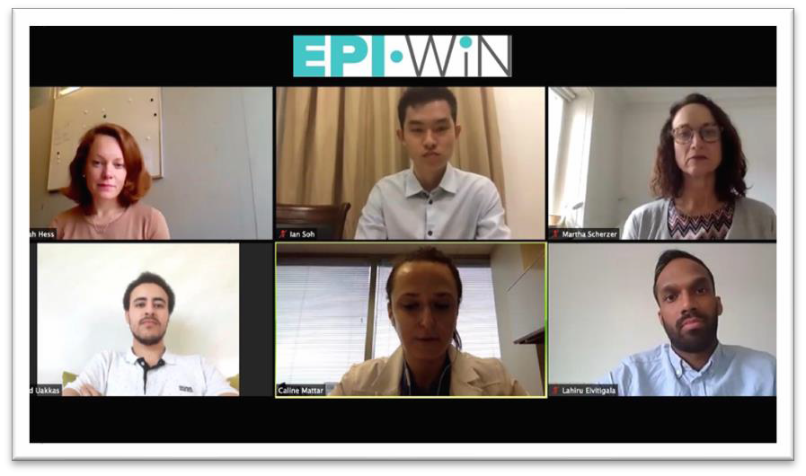
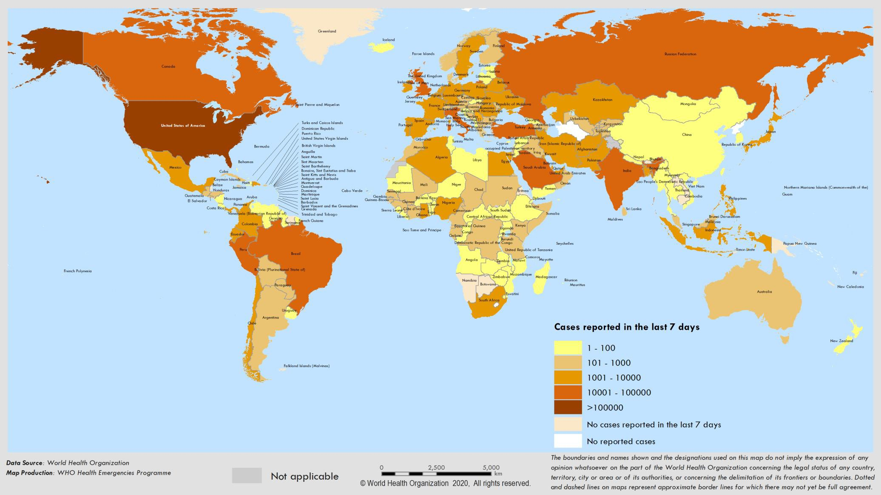
Surveillance
Figure 1. Number of confirmed COVID-19 cases reported in the last seven days by country, territory or area, 30 April to 6 May**

**See Annex 1 for data, table and figure notes.
Figure 2. Number of confirmed COVID-19 cases,by date of report and WHO region,30 December 2019 through 6 May 2020**
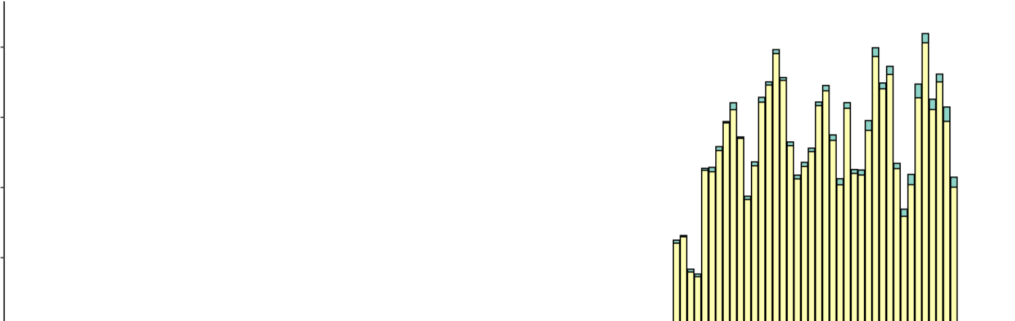

90000

80000

70000

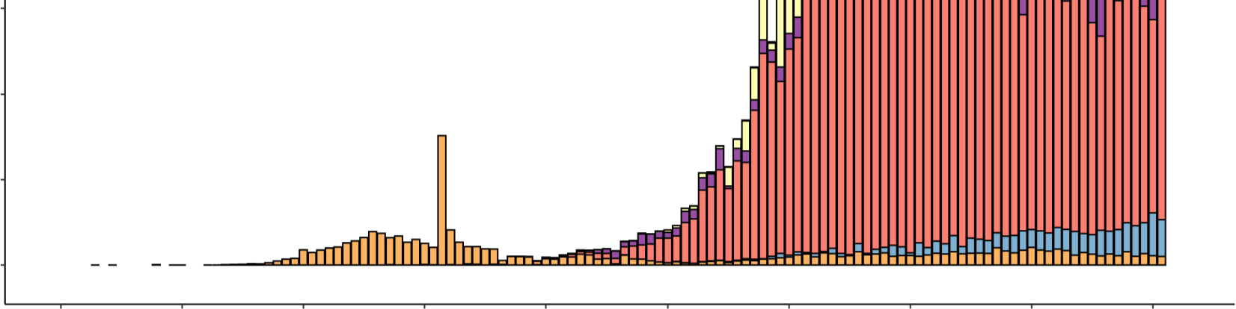

20000

10000

0
 | 30 Dec | 13 Jan | 27Jan | 10 Feb | 24 Feb | 09Mar | 23 Mar | 06Apr | 20Apr | 04May
 | 2019 | 2020 | 2020 | 2020 | 2020 | 2020 | 2020 | 2020 | 2020 | 2020
Date of report

**See Annex 1for data, table and figure notes.
Table 1. Countries, territories or areas with reported laboratory-confirmed COVID-19 cases and deaths, by WHO region. Data as of 10 AM CEST, 6 May 2020**

Reporting Country/ Territory/Area | Total confirmed cases | Total confirmed new cases | Total deaths | Total new deaths | Transmission classificationi | Days since last reported case
Africa

South Africa | 7439 | 219 | 148 | 10 | Community transmission | 0
Algeria | 4838 | 190 | 470 | 5 | Community transmission | 0
Nigeria | 2950 | 148 | 98 | 5 | Community transmission | 0
Ghana | 2719 | 0 | 18 | 0 | Clusters of cases | 1
Cameroon | 2265 | 188 | 108 | 44 | Clusters of cases | 0
Guinea | 1811 | 101 | 10 | 1 | Community transmission | 0
Côte d’Ivoire | 1464 | 32 | 18 | 1 | Clusters of cases | 0
Senegal | 1329 | 58 | 11 | 1 | Clusters of cases | 0
Niger | 763 | 8 | 38 | 1 | Clusters of cases | 0
Democratic Republic of the Congo | 705 | 23 | 34 | 0 | Clusters of cases | 0
Burkina Faso | 689 | 17 | 48 | 2 | Community transmission | 0
Mali | 612 | 32 | 32 | 3 | Clusters of cases | 0
Kenya | 535 | 45 | 23 | -1 | Clusters of cases | 0
United Republic of Tanzania | 480 | 0 | 18 | 0 | Clusters of cases | 6
Equatorial Guinea | 439 | 124 | 4 | 2 | Clusters of cases | 0
Gabon | 397 | 30 | 6 | 0 | Clusters of cases | 0
Mauritius | 332 | 0 | 10 | 0 | Community transmission | 9
Guinea-Bissau | 292 | 0 | 2 | 0 | Sporadic cases | 2
Rwanda | 261 | 0 | 0 | 0 | Clusters of cases | 1
Congo | 236 | 0 | 10 | 0 | Clusters of cases | 1
Sierra Leone | 199 | 21 | 11 | 2 | Clusters of cases | 0

Reporting Country/ Territory/Area | Total confirmed cases | Total confirmed new cases | Total deaths | Total new deaths | Transmission classificationi | Days since last reported case

Cabo Verde | 186 | 21 | 2 | 0 | Sporadic cases | 0
São Tomé and Príncipe | 171 | 10 | 3 | 0 | Sporadic cases | 0
Chad | 170 | 53 | 17 | 7 | Sporadic cases | 0
Liberia | 170 | 4 | 20 | 2 | Clusters of cases | 0
Madagascar | 158 | 0 | 0 | 0 | Clusters of cases | 1
Ethiopia | 145 | 5 | 4 | 1 | Clusters of cases | 0
Zambia | 137 | 0 | 4 | 1 | Sporadic cases | 1
Togo | 128 | 2 | 9 | 0 | Clusters of cases | 0
Eswatini | 119 | 3 | 1 | 0 | Sporadic cases | 0
Benin | 102 | 6 | 2 | 0 | Sporadic cases | 0
Uganda | 97 | 8 | 0 | 0 | Sporadic cases | 0
Central African Republic | 94 | 0 | 0 | 0 | Sporadic cases | 1
Mozambique | 80 | 0 | 0 | 0 | Sporadic cases | 2
South Sudan | 49 | 0 | 0 | 0 | Sporadic cases | 1
Malawi | 41 | 0 | 3 | 0 | Sporadic cases | 1
Eritrea | 39 | 0 | 0 | 0 | Sporadic cases | 17
Angola | 36 | 1 | 2 | 0 | Sporadic cases | 0
Zimbabwe | 34 | 0 | 4 | 0 | Sporadic cases | 4
Botswana | 23 | 0 | 1 | 0 | Sporadic cases | 7
Burundi | 19 | 0 | 1 | 0 | Sporadic cases | 3
Gambia | 17 | 0 | 1 | 0 | Sporadic cases | 3
Namibia | 16 | 0 | 0 | 0 | Sporadic cases | 30
Seychelles | 11 | 0 | 0 | 0 | Sporadic cases | 29

Reporting Country/ Territory/Area | Total confirmed cases | Total confirmed new cases | Total deaths | Total new deaths | Transmission classificationi | Days since last reported case

Mauritania | 8 | 0 | 1 | 0 | Sporadic cases | 5
Comoros | 4 | 0 | 1 | 0 | Pending | 1
Territoriesii
Mayotte | 739 | 53 | 9 | 3 | Clusters of cases | 0
Réunion | 425 | 1 | 0 | 0 | Clusters of cases | 0
Americas
United States of America | 1 171 185 | 16 200 | 62 698 | 792 | Community transmission | 0
Brazil | 107 780 | 6633 | 7321 | 296 | Community transmission | 0
Canada | 61 159 | 1315 | 3915 | 149 | Community transmission | 0
Peru | 47 372 | 1444 | 1344 | 58 | Community transmission | 0
Ecuador | 31 881 | 0 | 1569 | 0 | Community transmission | 1
Mexico | 24 905 | 1434 | 2271 | 117 | Community transmission | 0
Chile | 22 016 | 1373 | 275 | 5 | Community transmission | 0
Dominican Republic | 8480 | 245 | 354 | 8 | Community transmission | 0
Colombia | 7973 | 305 | 358 | 18 | Community transmission | 0
Panama | 7387 | 190 | 203 | 3 | Community transmission | 0
Argentina | 4922 | 123 | 262 | 12 | Community transmission | 0
Cuba | 1685 | 17 | 69 | 0 | Clusters of cases | 0
Bolivia (Plurinational State of) | 1681 | 87 | 82 | 6 | Clusters of cases | 0
Honduras | 1178 | 123 | 89 | 7 | Clusters of cases | 0
Costa Rica | 742 | 3 | 6 | 0 | Clusters of cases | 0
Guatemala | 730 | 27 | 19 | 2 | Clusters of cases | 0
Uruguay | 657 | 2 | 17 | 0 | Clusters of cases | 0
El Salvador | 587 | 32 | 13 | 1 | Clusters of cases | 0

Reporting Country/ Territory/Area | Total confirmed cases | Total confirmed new cases | Total deaths | Total new deaths | Transmission classificationi | Days since last reported case

Jamaica | 471 | 2 | 9 | 0 | Clusters of cases | 0
Paraguay | 431 | 35 | 10 | 0 | Community transmission | 0
Venezuela (Bolivarian Republic of) | 361 | 4 | 10 | 0 | Clusters of cases | 0
Trinidad and Tobago | 116 | 0 | 8 | 0 | Sporadic cases | 8
Haiti | 100 | 12 | 11 | 2 | Clusters of cases | 0
Guyana | 92 | 10 | 9 | 0 | Clusters of cases | 0
Bahamas | 84 | 1 | 11 | 0 | Clusters of cases | 0
Barbados | 82 | 0 | 7 | 0 | Clusters of cases | 1
Antigua and Barbuda | 25 | 0 | 3 | 0 | Clusters of cases | 2
Grenada | 21 | 0 | 0 | 0 | Clusters of cases | 2
Belize | 18 | 0 | 2 | 0 | Sporadic cases | 21
Saint Lucia | 18 | 0 | 0 | 0 | Sporadic cases | 1
Saint Vincent and the Grenadines | 17 | 0 | 0 | 0 | Sporadic cases | 1
Dominica | 16 | 0 | 0 | 0 | Clusters of cases | 25
Nicaragua | 15 | 0 | 5 | 0 | Pending | 1
Saint Kitts and Nevis | 15 | 0 | 0 | 0 | Sporadic cases | 15
Suriname | 10 | 0 | 1 | 0 | Sporadic cases | 32
Territoriesii
Puerto Rico | 1924 | 81 | 56 | 2 | Clusters of cases | 0
Martinique | 181 | 0 | 14 | 0 | Clusters of cases | 2
Guadeloupe | 152 | 0 | 13 | 1 | Clusters of cases | 5
French Guiana | 133 | 0 | 1 | 0 | Clusters of cases | 1

Reporting Country/ Territory/Area | Total confirmed cases | Total confirmed new cases | Total deaths | Total new deaths | Transmission classificationi | Days since last reported case

Bermuda | 115 | 0 | 7 | 0 | Clusters of cases | 2
Aruba | 101 | 1 | 2 | 0 | Clusters of cases | 0
Sint Maarten | 76 | 0 | 14 | 1 | Clusters of cases | 5
Cayman Islands | 75 | 1 | 1 | 0 | Clusters of cases | 0
United States Virgin Islands | 66 | 0 | 4 | 0 | Clusters of cases | 5
Saint Martin | 38 | 0 | 3 | 0 | Sporadic cases | 13
Curaçao | 16 | 0 | 1 | 0 | Sporadic cases | 8
Falkland Islands (Malvinas) | 13 | 0 | 0 | 0 | Clusters of cases | 10
Turks and Caicos Islands | 12 | 0 | 1 | 0 | Sporadic cases | 8
Montserrat | 11 | 0 | 1 | 0 | Sporadic cases | 22
British Virgin Islands | 7 | 1 | 1 | 0 | Sporadic cases | 0
Bonaire, Sint Eustatius and Saba | 6 | 0 | 0 | 0 | Sporadic cases | 8
Saint Barthélemy | 6 | 0 | 0 | 0 | Sporadic cases | 36
Anguilla | 3 | 0 | 0 | 0 | Sporadic cases | 32
Saint Pierre and Miquelon | 1 | 0 | 0 | 0 | Sporadic cases | 28
Eastern Mediterranean
Iran (Islamic Republic of) | 99 970 | 1323 | 6340 | 63 | Community transmission | 0
Saudi Arabia | 30 251 | 1595 | 200 | 9 | Clusters of cases | 0
Pakistan | 22 533 | 1032 | 526 | 40 | Clusters of cases | 0
Qatar | 17 142 | 951 | 12 | 0 | Community transmission | 0
United Arab Emirates | 15 192 | 462 | 146 | 9 | Pending | 0
Egypt | 7201 | 388 | 452 | 16 | Clusters of cases | 0
Kuwait | 5804 | 526 | 40 | 0 | Clusters of cases | 0

Reporting Country/ Territory/Area | Total confirmed cases | Total confirmed new cases | Total deaths | Total new deaths | Transmission classificationi | Days since last reported case

Morocco | 5219 | 166 | 181 | 2 | Clusters of cases | 0
Bahrain | 3720 | 187 | 8 | 0 | Clusters of cases | 0
Afghanistan | 3224 | 755 | 95 | 23 | Clusters of cases | 0
Oman | 2903 | 168 | 13 | 1 | Clusters of cases | 0
Iraq | 2431 | 85 | 102 | 4 | Clusters of cases | 0
Djibouti | 1120 | 4 | 2 | 0 | Clusters of cases | 0
Tunisia | 1022 | 4 | 43 | 0 | Community transmission | 0
Somalia | 835 | 79 | 38 | 3 | Sporadic cases | 0
Sudan | 778 | 100 | 45 | 4 | Sporadic cases | 0
Lebanon | 741 | 1 | 25 | 0 | Clusters of cases | 0
Jordan | 471 | 6 | 9 | 0 | Clusters of cases | 0
Libya | 63 | 0 | 3 | 0 | Clusters of cases | 4
Syrian Arab Republic | 44 | 0 | 3 | 0 | Community transmission | 4
Yemen | 23 | 11 | 3 | 1 | Pending | 0
Territoriesii
occupied Palestinian territory | 543 | 11 | 4 | 0 | Clusters of cases | 0
Europe
Spain | 219 329 | 1318 | 25 613 | 185 | Community transmission | 0
Italy | 213 013 | 1075 | 29 315 | 236 | Community transmission | 0
The United Kingdom | 194 994 | 4406 | 29 427 | 693 | Community transmission | 0
Russian Federation | 165 929 | 10 559 | 1537 | 86 | Clusters of cases | 0
Germany | 164 897 | 1037 | 6996 | 165 | Community transmission | 0
France | 131 292 | 1050 | 25491 | 326 | Community transmission | 0
Turkey | 129 491 | 1832 | 3520 | 59 | Community transmission | 0

Reporting Country/ Territory/Area | Total confirmed cases | Total confirmed new cases | Total deaths | Total new deaths | Transmission classificationi | Days since last reported case

Belgium | 50 509 | 242 | 8016 | 92 | Community transmission | 0
Netherlands | 41 087 | 317 | 5168 | 86 | Community transmission | 0
Switzerland | 29 926 | 28 | 1482 | 6 | Community transmission | 0
Portugal | 25 702 | 178 | 1074 | 11 | Community transmission | 0
Sweden | 23 216 | 495 | 2854 | 85 | Community transmission | 0
Ireland | 21 983 | 261 | 1339 | 20 | Community transmission | 0
Belarus | 19 255 | 1766 | 112 | 9 | Clusters of cases | 0
Israel | 16 268 | 31 | 237 | 3 | Pending | 0
Austria | 15 586 | 17 | 606 | 6 | Community transmission | 0
Poland | 14 431 | 425 | 716 | 18 | Community transmission | 0
Romania | 13 837 | 325 | 827 | 24 | Community transmission | 0
Ukraine | 13 184 | 487 | 327 | 11 | Community transmission | 0
Denmark | 9821 | 151 | 503 | 10 | Pending | 0
Serbia | 9677 | 120 | 200 | 3 | Pending | 0
Norway | 7903 | 56 | 209 | 1 | Pending | 0
Czechia | 7896 | 77 | 257 | 5 | Community transmission | 0
Finland | 5412 | 85 | 246 | 6 | Pending | 0
Republic of Moldova | 4363 | 115 | 140 | 7 | Pending | 0
Kazakhstan | 4298 | 138 | 29 | 0 | Pending | 0
Luxembourg | 3840 | 12 | 96 | 0 | Pending | 0
Hungary | 3111 | 46 | 373 | 10 | Clusters of cases | 0
Armenia | 2782 | 163 | 40 | 0 | Clusters of cases | 0
Greece | 2642 | 10 | 146 | 0 | Community transmission | 0
Uzbekistan | 2217 | 28 | 10 | 0 | Clusters of cases | 0

Reporting Country/ Territory/Area | Total confirmed cases | Total confirmed new cases | Total deaths | Total new deaths | Transmission classificationi | Days since last reported case

Croatia | 2112 | 11 | 83 | 3 | Community transmission | 0
Azerbaijan | 2060 | 76 | 26 | 0 | Clusters of cases | 0
Bosnia and Herzegovina | 1968 | 42 | 82 | 5 | Community transmission | 0
Iceland | 1799 | 0 | 10 | 0 | Community transmission | 2
Estonia | 1711 | 8 | 55 | 0 | Pending | 0
Bulgaria | 1689 | 37 | 78 | 0 | Clusters of cases | 0
North Macedonia | 1526 | 8 | 86 | 1 | Clusters of cases | 0
Slovenia | 1445 | 6 | 98 | 1 | Community transmission | 0
Lithuania | 1423 | 4 | 46 | 0 | Community transmission | 0
Slovakia | 1421 | 8 | 25 | 0 | Clusters of cases | 0
Latvia | 896 | 0 | 17 | 1 | Community transmission | 1
Cyprus | 878 | 4 | 20 | 0 | Clusters of cases | 0
Kyrgyzstan | 871 | 28 | 12 | 2 | Clusters of cases | 0
Albania | 832 | 12 | 31 | 0 | Clusters of cases | 0
Andorra | 751 | 0 | 46 | 1 | Community transmission | 1
Georgia | 610 | 6 | 9 | 0 | Community transmission | 0
San Marino | 589 | 7 | 41 | 0 | Community transmission | 0
Malta | 482 | 2 | 5 | 1 | Pending | 0
Montenegro | 324 | 1 | 8 | 0 | Clusters of cases | 0
Tajikistan | 293 | 63 | 7 | 0 | Pending | 0
Monaco | 95 | 0 | 1 | 0 | Sporadic cases | 2
Liechtenstein | 83 | 0 | 1 | 0 | Pending | 10
Holy See | 11 | 0 | 0 | 0 | Sporadic cases | 5

Reporting Country/ Territory/Area | Total confirmed cases | Total confirmed new cases | Total deaths | Total new deaths | Transmission classificationi | Days since last reported case
Territoriesii

Kosovo[1]

856 1 27 0 Community transmission 0

Isle of Man 325 4 23 0 Pending 0
Jersey 293 1 24 0 Pending 0
Guernsey 252 0 13 0 Community transmission 3
Faroe Islands 187 0 0 0 Pending 12
Gibraltar 144 0 0 0 Clusters of cases 4
Greenland 11 0 0 0 Pending 30
South-East Asia
India 49 391 2958 1694 126 Clusters of cases 0
Indonesia 12 071 484 872 8 Community transmission 0
Bangladesh 10 929 786 183 1 Clusters of cases 0
Thailand 2989 1 55 1 Clusters of cases 0
Sri Lanka 771 53 9 2 Clusters of cases 0
Maldives 573 28 2 1 Clusters of cases 0
Myanmar 161 0 6 0 Clusters of cases 1
Nepal 82 0 0 0 Sporadic cases 1
Timor-Leste 24 0 0 0 Clusters of cases 12
Bhutan 7 0 0 0 Sporadic cases 13
Western Pacific
China 84 406 2 4643 0 Clusters of cases 0
Singapore 19 410 632 18 0 Clusters of cases 0
Japan 15 354 123 543 22 Clusters of cases 0

Reporting Country/ Territory/Area | Total confirmed cases | Total confirmed new cases | Total deaths | Total new deaths | Transmission classificationi | Days since last reported case

Republic of Korea | 10 806 | 2 | 255 | 1 | Clusters of cases | 0
Philippines | 9684 | 199 | 637 | 14 | Clusters of cases | 0
Australia | 6849 | 24 | 96 | 1 | Clusters of cases | 0
Malaysia | 6383 | 30 | 106 | 1 | Clusters of cases | 0
New Zealand | 1138 | 1 | 21 | 1 | Clusters of cases | 0
Viet Nam | 271 | 0 | 0 | 0 | Clusters of cases | 2
Brunei Darussalam | 138 | 0 | 1 | 0 | Sporadic cases | 16
Cambodia | 122 | 0 | 0 | 0 | Sporadic cases | 24
Mongolia | 41 | 1 | 0 | 0 | Sporadic cases | 0
Lao People's Democratic Republic | 19 | 0 | 0 | 0 | Sporadic cases | 23
Fiji | 18 | 0 | 0 | 0 | Sporadic cases | 15
Papua New Guinea | 8 | 0 | 0 | 0 | Sporadic cases | 13
Territoriesii
Guam | 145 | 0 | 5 | 0 | Clusters of cases | 2
French Polynesia | 60 | 2 | 0 | 0 | Sporadic cases | 0
New Caledonia | 18 | 0 | 0 | 0 | Sporadic cases | 33
Northern Mariana Islands (Commonwealth of the) | 14 | 0 | 2 | 0 | Pending | 18

Other* 712 0 13 0 - 51
Subtotal for all regions | 3 588 061 | 71 463 | 247 490 | 4102

Grand total | 3 588 773 | 71 463 | 247 503 | 4102
**See Annex 1 for data, table and figure notes.
Technical guidance and other resources
- To view all technical guidance documents regarding COVID-19, please go to this webpage.
- Updates from WHO regional offices
– WHO AFRO | – WHO PAHO
– WHO EMRO | – WHO SEARO
– WHO EURO | – WHO WPRO

- Research and Development
- Online courses on COVID-19 and in additional national languages
- The Strategic Preparedness and Response Plan (SPRP) outlining the support the international community can provide to all countries to prepare and respond to the virus.
- WHO Health Emergency dashboard
- Weekly COVID-19 Operations Updates

Recommendations and advice for the public
- Protect yourself.
- Questions and answers
- Travel advice
- EPI-WIN: tailored information for individuals, organizations and communities

Case definitions
WHO periodically updates the Global Surveillance for human infection with coronavirus disease (COVID-19) document which includes surveillance definitions.
Definition of COVID-19 death
COVID-19 death is defined for surveillance purposes as a death resulting from a clinically compatible illness in a probable or confirmed COVID-19 case, unless there is a clear alternative cause of death that cannot be related to COVID disease (e.g. trauma). There should be no period of complete recovery between the illness and death.
Annex 1: Data, table and figure notes
Caution must be taken when interpreting all data presented. Differences are to be expected between information products published by WHO, national public health authorities, and other sources using different inclusion criteria and different data cut-off times. While steps are taken to ensure accuracy and reliability, all data are subject to continuous verification and change. Case detection, definitions, testing strategies, reporting practice, and lag times differ between countries/territories/areas. These factors, amongst others, influence the counts presented with variable underestimation of true case and death counts, and variable delays to reflecting these data at global level.
The designations employed, and the presentation of these materials do not imply the expression of any opinion whatsoever on the part of WHO concerning the legal status of any country, territory or area or of its authorities, or concerning the delimitation of its frontiers or boundaries. Dotted and dashed lines on maps represent approximate border lines for which there may not yet be full agreement. Countries, territories and areas are arranged under the administering WHO region.
[1] All references to Kosovo should be understood to be in the context of the United Nations Security Council resolution 1244 (1999).
In the map, number of cases of Serbia and Kosovo (UNSCR 1244, 1999) have been aggregated for visualization purposes.

Counts reflect laboratory-confirmed cases and deaths, based on WHO case definitions unless stated otherwise (see Country, territory, or area-specific updates and errata), and include both domestic and repatriated cases.
Other*: includes cases and deaths reported under the international conveyance (Diamond Princess).
Due to the recent trend of countries conducting data reconciliation exercises which remove large numbers of cases or deaths from their total counts, WHO will now display such data as negative numbers in the “new cases” / “new deaths” columns as appropriate. This will aid readers in identifying when such reconciliation exercises have taken place. When additional details become available in future which allow the subtractions to be apportioned to previous days, numbers will be updated accordingly. Prior situation reports will not be retrospectively updated; the most up-to- date data can always be found at covid19.who.int
Additional table notes
i Transmission classification is based on a process of country/territory/area self-reporting. Classifications are reviewed on a weekly basis, may be revised as new information becomes available, and are based on the highest category reported. Differing degrees of transmission may be present within countries/territories/areas. Categories:
- No cases: with no confirmed cases (not shown in table).
- Sporadic cases: with one or more cases, imported or locally detected.
- Clusters of cases: experiencing cases, clustered in time, geographic location and/or by common exposures.
- Community transmission: experiencing larger outbreaks of local transmission defined through an assessment of factors including, but not limited to: large numbers of cases not linkable to transmission chains; large numbers of cases from sentinel lab surveillance; and/or multiple unrelated clusters in several areas of the country/territory/area.
- Pending: transmission classification not been reported to WHO.
ii “Territories” include territories, areas, overseas dependencies and other jurisdictions of similar status.
Country, territory, or area-specific updates and errata
The numbers of cases for Austria and Albania have been revised.

